**Web Programming**

**(LAB Session-13)**

**Working with PHP and MySQL**

**Developing Admin Panel for a university result website**

**Q) You are designing an interface for the students to check their result. This LAB task is divided into two Lab practical. In the first part, we are going to design an admin page from where the authorities can enter marks for the students. You need to design an input form which will look like below.**

**A) Create a php page where the data will be sent on submission of this form.**

**B) Create a MySQL Database called resultDB with a table named sem6_result.**

**C) Create appropriate column to store the form data into the table.**

**D) Store the data received from the form into the database as shown below.**

**E) Submit at least 10 student result into the database.**

**F) Take a screenshot of table from phpMyAdmin after inserting 10 data into the table.**

**Your submission should contain source code and output screenshot as per above instruction**

**CODE:**

**adminenter.php**

**<!DOCTYPE html>**

**<html>**

**<head>**

**<title>Result Enter Panel</title>**

**<link rel="stylesheet" href="register.css">**

**</head>**

**<body>**

**<h1 id="reg_text">Registration</h1>**

**<form id="form" action="datafill.php" method="get">**

**<fieldset class="field">**

**<legend>Personal Details</legend>**

**<table class="table">**

**<tr>**

**<td><label for="name">Name:</label></td>**

**<td><input type="text" id="name" name="name" placeholder="Enter the name"><br></td>**

**</tr>**

**<tr>**

**<td><label for="enroll">Enrollment No.:</label></td>**

**<td><input type="number" id="enroll" name="enroll" placeholder="Enter the enrollment number"><br>**

**</td>**

**</tr>**

**<H2> Enter Grades for below subjects --> </H2>**

**<tr>**

**<td><label for="wp">Web Devlopment : </label></td>**

**<td>**

**<select name="wp" id="wp">**

**<option value="Select">Select</option>**

**<option value="AA">AA</option>**

**<option value="AB">AB</option>**

**<option value="BB">BB</option>**

**<option value="BC">BC</option>**

**<option value="CC">CC</option>**

**<option value="CD">CD</option>**

**<option value="DD">DD</option>**

**<option value="FF">FF</option>**

**</select>**

**</td>**

**</tr>**

**<tr>**

**<td><label for="toc">Thoery of Computation : </label></td>**

**<td>**

**<select name="toc" id="toc">**

**<option value="Select">Select</option>**

**<option value="AA">AA</option>**

**<option value="AB">AB</option>**

**<option value="BB">BB</option>**

**<option value="BC">BC</option>**

**<option value="CC">CC</option>**

**<option value="CD">CD</option>**

**<option value="DD">DD</option>**

**<option value="FF">FF</option>**

**</select>**

**</td>**

**</tr>**

**<tr>**

**<td><label for="mpi">Micro Processor & Interfacing : </label></td>**

**<td>**

**<select name="mpi" id="mpi">**

**<option value="Select">Select</option>**

**<option value="AA">AA</option>**

**<option value="AB">AB</option>**

**<option value="BB">BB</option>**

**<option value="BC">BC</option>**

**<option value="CC">CC</option>**

**<option value="CD">CD</option>**

**<option value="DD">DD</option>**

**<option value="FF">FF</option>**

**</select>**

**</td>**

**</tr>**

**<tr>**

**<td><label for="ajp">Advance Java Programming : </label></td>**

**<td>**

**<select name="ajp" id="ajp">**

**<option value="Select">Select</option>**

**<option value="AA">AA</option>**

**<option value="AB">AB</option>**

**<option value="BB">BB</option>**

**<option value="BC">BC</option>**

**<option value="CC">CC</option>**

**<option value="CD">CD</option>**

**<option value="DD">DD</option>**

**<option value="FF">FF</option>**

**</select>**

**</td>**

**</tr>**

**<tr>**

**<td><label for="iot">Internet Of Things : </label></td>**

**<td>**

**<select name="iot" id="iot">**

**<option value="Select">Select</option>**

**<option value="AA">AA</option>**

**<option value="AB">AB</option>**

**<option value="BB">BB</option>**

**<option value="BC">BC</option>**

**<option value="CC">CC</option>**

**<option value="CD">CD</option>**

**<option value="DD">DD</option>**

**<option value="FF">FF</option>**

**</select>**

**</td>**

**</tr>**

**<tr>**

**<td><label for="dv">Data Visulization : </label></td>**

**<td>**

**<select name="dv" id="dv">**

**<option value="Select">Select</option>**

**<option value="AA">AA</option>**

**<option value="AB">AB</option>**

**<option value="BB">BB</option>**

**<option value="BC">BC</option>**

**<option value="CC">CC</option>**

**<option value="CD">CD</option>**

**<option value="DD">DD</option>**

**<option value="FF">FF</option>**

**</select>**

**</td>**

**</tr>**

**</table>**

**</fieldset>**

**<table class="table">**

**<tr>**

**<td><input type="submit" value="Submit" class="submit_btn"></td>**

**</tr>**

**</table>**

**</form>**

**</body>**

**</html>**

**databasecreste.php**

**<!DOCTYPE html>**

**<html>**

**<head>**

**<title>DATABAE CREATE</title>**

**</head>**

**<body>**

**<?php**

**$server = "localhost";**

**$user = "root";**

**$pass = "";**

**$db = "Result";**

**$conn = mysqli_connect($server, $user, $pass, $db);**

**if(!$conn) {**

**die("Connection failed: ".mysqli_connect_error());**

**}**

**$sql = "CREATE TABLE SEM6_result ( id INT(6) UNSIGNED AUTO_INCREMENT PRIMARY KEY,**

**enroll BIGINT(18) NOT NULL,**

**Name VARCHAR(20) NOT NULL,**

**WP VARCHAR(2) NOT NULL,**

**TOC VARCHAR(2) NOT NULL,**

**MPI VARCHAR(2) NOT NULL,**

**AJP VARCHAR(2) NOT NULL,**

**IOT VARCHAR(2) NOT NULL,**

**DV VARCHAR(2) NOT NULL,**

**TimeStamp TIMESTAMP)";**

**if(mysqli_query($conn, $sql)){**

**echo "<div class='container'><div class='jumbotron'> <H3>Result TABLE created Successfully</H3></div></div>";**

**}**

**else{**

**echo "Error in creating Table :". mysqli_error($conn);**

**}**

**mysqli_close($conn);**

**?>**

**</body>**

**</html>**

**datafill.php**

**<!DOCTYPE html>**

**<html>**

**<head>**

**<title>DATABAE CREATE</title>**

**</head>**

**<body>**

**<?php**

**$server = "localhost";**

**$user = "root";**

**$pass = "";**

**$db = "Result";**

**$conn = mysqli_connect($server, $user, $pass, $db);**

**if(!$conn) {**

**die("Connection failed: ".mysqli_connect_error());**

**}**

**$stmt = $conn->prepare("INSERT INTO SEM6_result (enroll, Name, WP, TOC, MPI, AJP, IOT, DV) VALUES (?, ?, ?, ?, ?, ?, ?, ?)");**

**$stmt->bind_param("isssssss",$enroll, $name, $wp, $toc, $mpi, $ajp, $iot, $dv);**

**$enroll = $_GET["enroll"];**

**$name = $_GET["name"];**

**$wp = $_GET["wp"];**

**$toc = $_GET["toc"];**

**$mpi = $_GET["mpi"];**

**$ajp = $_GET["ajp"];**

**$iot = $_GET["iot"];**

**$dv = $_GET["dv"];**

**$stmt->execute();**

**echo "<div class='container'><div class='jumbotron'> <H3>Result is successfully stored into Database.</H3></div></div>";**

**?>**

**</body>**

**</html>**

**Output:**

**DATABASE CREATE**

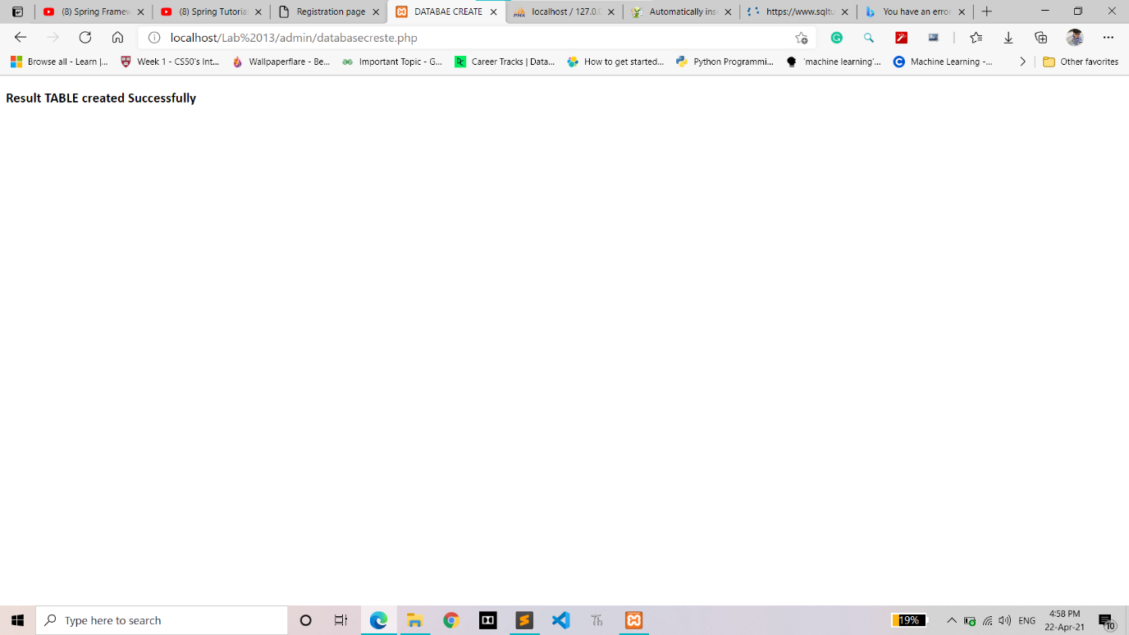

**DATABSE OUTPUT** 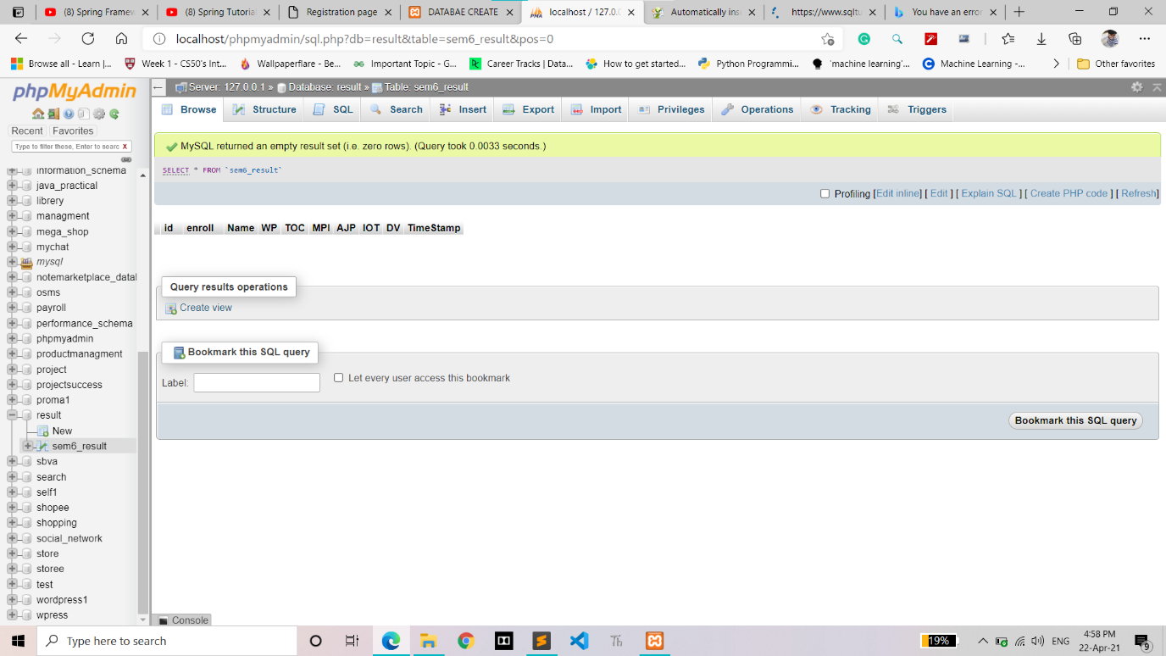

**Fill User information**

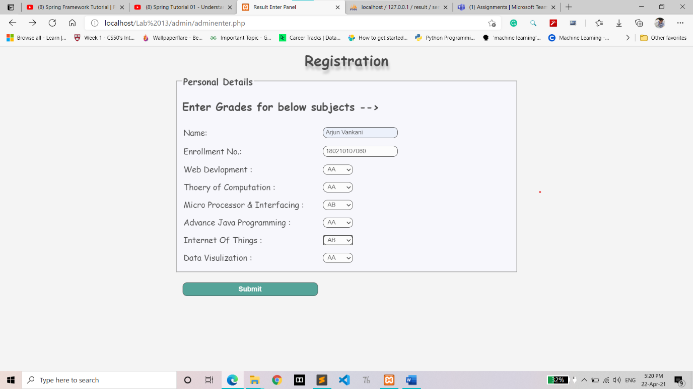

**Succesfully stored data**

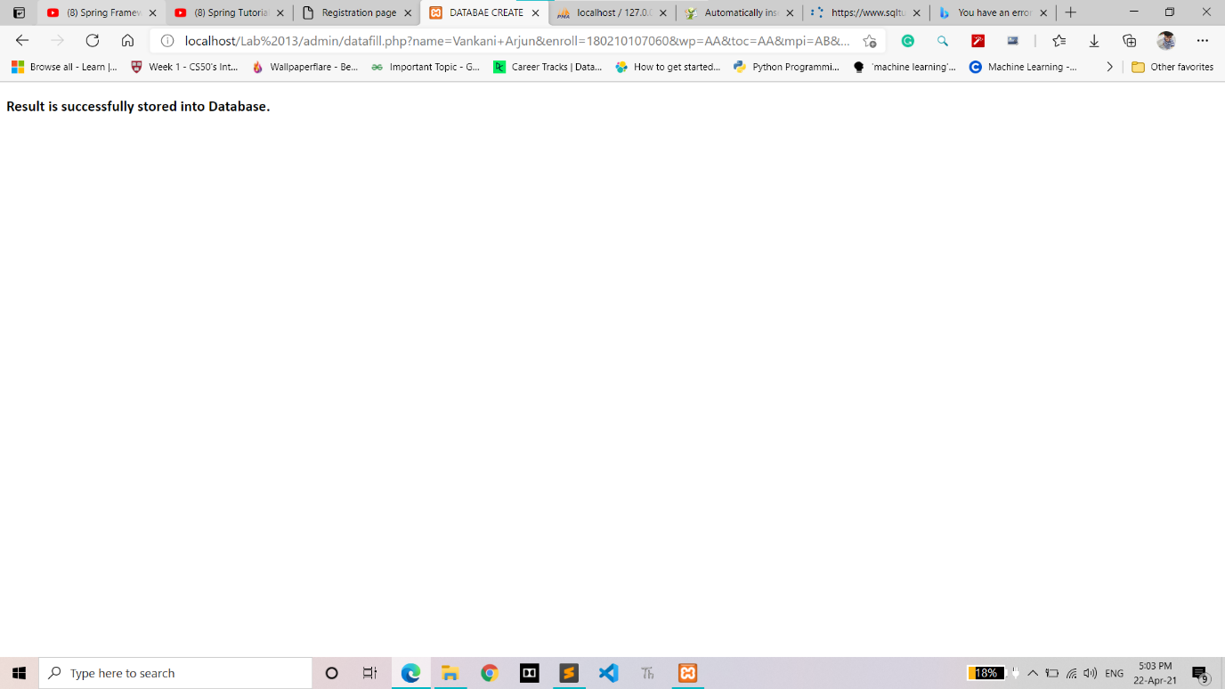

**User information list into Phpmyadmin**

